|  |
| --- |
|  |

|  |  |  |
| --- | --- | --- |
|  |  |  |
|  | [Type the recipient name] |  |
|  | [Type recipient address]  Phone: [Type the recipient phone number] |  |

Dear Sir/Ma’am:

As a member of your constituency from **[Type the County Name Here]** County, I wanted to bring to your attention an issue that concerns my personal liberties. There has been a recent document, titled “Motor Vehicle Division [*Policy Bulletin MVD-2023-05*](https://dor.georgia.gov/document/document/policy-bulletin-mvd-2023-05-japanese-kei-vehicles-and-minitruckspdf/download)” that has directed the GA DOR-MVD to “cancel the title and revoke the registration” of a small subset of imported vehicles they define as Japanese ‘kei’ vehicles.

These vehicles (which must be over 25 years old) have been legally imported into the USA, legally titled and registered in Georgia, and all taxes paid. Furthermore, the law has NOT changed. This is a government bureaucracy spending GA tax dollars to seek out and destroy the ability to use their property legally as they see fit.

The document references O.C.G.A. § 40-3- 30.1(f) as a law justifying this behavior, however this is not a new law, and the code has many parts, including O.C.G.A. § 40-3- 30(b) which excludes vehicles over 25 years old from the rest of the code. It specifically says that these vehicles are legal! The current GA DOR-MVD leadership is misinterpreting the law and over-reaching their authority.

The document also references a minitruck report by AAMVA as proof that kei vehicles are dangerous. This report did *not* involve any kei vehicles! The crash test involves a Chinese ChangAn Tiger Star Minitruck. Kei vehicles are Japanese made, to Japanese standards by well-known manufacturers like Honda, Suzuki, & Mazda, & have far more substantial crash protection & quality control.

If GA wants to exclude vehicles that do not meet FMVSS, then they must pass a new law. They can’t target a specific subset of vehicles & allow other vehicles that do not meet FMVSS requirements (like almost all vintage vehicles) to remain. Until then, let GA taxpayers live their lives, and choose their transport knowing that older vehicles, like motorcycles, vintage vehicles, or even lifted trucks, might have more risk for their own safety.

The recent passage of HB 121 that allows the registration of UTVs shows that the government of GA agrees that individuals are responsible for their own risk. This should reasonably extend to the owners of imported vintage vehicles, as the current law allows.

I humbly ask for the following actions to take place:

* Immediate ceasing of the GA DOR-MVD targeting these citizens and canceling their titles and/or registrations
* The allowance for current title holders to renew their registration without obstruction
* Investigation into the current enforcement of vintage imported vehicles – it should be fair and just, not biased

Thank you for your time & courtesy, and I trust you will investigate this matter. Additional information is attached.

Sincerely,

[Type the sender name]

[Type the sender title]

[Type the sender company name]

Date

Motor Vehicle Division [*Policy Bulletin MVD-2023-05*](https://dor.georgia.gov/document/document/policy-bulletin-mvd-2023-05-japanese-kei-vehicles-and-minitruckspdf/download) (concerning the targeting of currently registered vehicles)

<https://dor.georgia.gov/document/document/policy-bulletin-mvd-2023-05-japanese-kei-vehicles-and-minitruckspdf/download>

Motor Vehicle Division *Policy Bulletin MVD-2023-04 (allowing UTVs, with no safety protections, to be registered!)*

<https://dor.georgia.gov/document/document/policy-bulletin-mvd-2023-04-registering-multipurpose-highway-motor-vehicles/download>

AAMVA Report on CHINESE made minitrucks (no kei vehicles anywhere in this document)

<https://www.iihs.org/media/b7dbab02-4fc5-429c-b254-c5c70af6a622/0U7wZA/RegulatoryComments/aamva_minitruck-lsv_letter.pdf>

The above document also states specifically that GA has *no current law* that prohibits these vehicles for on-road use.

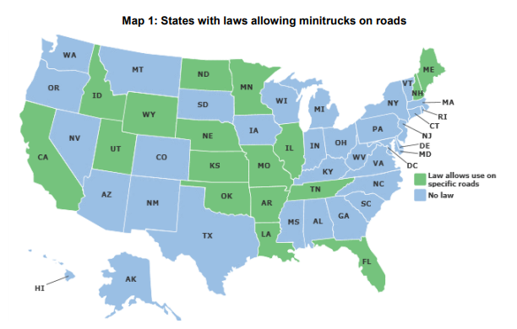

Ga. Code § 40-3-30

<https://casetext.com/statute/code-of-georgia/title-40-motor-vehicles-and-traffic/chapter-3-certificates-of-title-security-interests-and-liens/article-2-certificates-of-title/section-40-3-30-requirement-of-compliance-with-federal-safety-standards>

Relevant Text:

**(b)** The provisions of subsection (a) of this Code section shall not apply to applications for certificates of title for such motor vehicles first titled in Georgia that have a manufactured date that is 25 years or older at the time of application. Certification of compliance shall only be required at the time of application for the issuance of the initial Georgia certificate of title.

GA law prevents retroactively withdrawing compliance! The GA DOR-MVD cannot legally pursue citizens which already have written compliance (legal titles and registration)